**Leader Overview**



**Volume Overview**

**Expect the Unexpected**

*We all make plans—plans for where we’re going and what we want to do. But life is more often a story of unexpected interruptions. Our faith helps us to recognize God’s hand at work in unanticipated ways. By faith we learn to embrace life’s interruptions as the place God so often does miraculous things. We learn to respond with compassion and faith when things seem impossible.*

**Session Overview**

**Allow for Redirection**

*In this* **Live** *session, kids will discover how Jesus took the time to have a life-changing conversation with a woman at a well. Kids will learn that they need to welcome God’s redirection and allow Jesus to write their story. When it comes from Jesus, change and redirection will always be the best thing for our life.*

**Bible Lesson**

A Woman’s Life Is Changed at a Well

[John 4:5–30](https://ref.ly/logosref/Bible.Jn4.5-30)

**Faith Fact**

I will let Jesus write my story.

**Faith Verse**

[Proverbs 3:5–6](https://ref.ly/logosref/Bible.Pr3.5-6) (NLT)

Trust in the Lord with all your heart; do not depend on your own understanding. Seek his will in all you do, and he will show you which path to take.

**Preparing for the Session**

**Leader Preparation Time: 20–25 Minutes**

|  |
| --- |
| ***You Will Need***  ***Large Group***   * *Bible* * *Worship songs (Song suggestions: “Way Maker” by Leeland; “Surrounded (Fight My Battles)” by Bethel Music; “Battle Belongs” by Phil Wickham; “Zeal” Lyric Video by The Belonging Co)* * *For groups not using a phone or tablet only, add:*   *• Projector or TV*  *• Laptop*  *•* ***Countdown60 Video–60 seconds***  ***• Faith Fact Slide***  ***• Faith Verse Video*** *or* ***Slide***  ***• Bible Lesson Video***  ***• Teaching Point Slides 1–3***   * *Twenty plastic drinking cups* * *Two table tennis balls* * *Two bowls of water* * *Six matching spoons* * *Two straws* * *Permanent marker* * *Table* * *Plastic table cover* * *Bottle of water*   ***Small Group***   * *Ball* * *Bibles for kids in the group to share* * *Whiteboard* * *Dry erase marker* * *Whiteboard eraser* * ***Small Group Activity Page****, one per kid* * *Pencils or pens, one per kid* * *Crayons or markers*   *To access session content and videos from a computer, visit:* [*BibleEngagementProject.com/downloads*](https://bibleengagementproject.com/downloads) |
| ***Getting Ready***  ***Large Group***   * *Download videos and slides if needed.* * *Select worship song(s) and have them ready to play.* * *Read the Bible Lesson Scripture to prepare for Teaching Time.* * *Mark the rim of two cups using a permanent marker, so you can see the mark when cups are stacked.* * *Set up the table and cover the table with a plastic table cover.* * *Place two bowls of water and spoons on the table.*   ***Small Group***   * *Write the Faith Verse on the whiteboard.* * *Print copies of the* ***Small Group Activity Page****, one per kid.*   *First time leading* Live *for Kids? Check out the* [*Facilitator Guide*](https://0b769b0ed3569ef9d18b-f88d8272f61086866d50d048b43ef630.ssl.cf2.rackcdn.com/sites/biblengagementproject/Listen_Facilitator_Guide.pdf)*.* |

**Large Group**

**30 Minutes**

*See what’s needed at the beginning of the session.*

**Introduction**

Hello, my friends! What’s something unexpected or surprising that happened to you this past week? *(Allow responses.)* Unexpected things happen to all of us, and sometimes they are part of God’s plan. Being ready for something unplanned, good or bad, means letting God change your direction. Raise your hand if you like plan changes and surprises. *(Group response)* Raise your hand if you like it when things stay the same. *(Group response)* A lot of us want our life to be steady and just what we expect. Life feels safer and easier that way. But when God wants to change our direction, we need to trust Him and leave behind what we’ve got planned.

• *Insert a personal story about a time when God redirected your life or changed your plans. Share how it changed your life for the better. Try to keep it light and something kids can relate to if possible.*

**Faith Fact**

Do you like reading or listening to a good story? *(Group response.)* A lot of our favorite books, TV shows, and movies are based on good stories. The best way to have a good life story of our own is to follow Jesus and ask Him to guide us. Our Faith Fact today is **I will let Jesus write my story.**

• *Show the* ***Faith Fact Slide.***

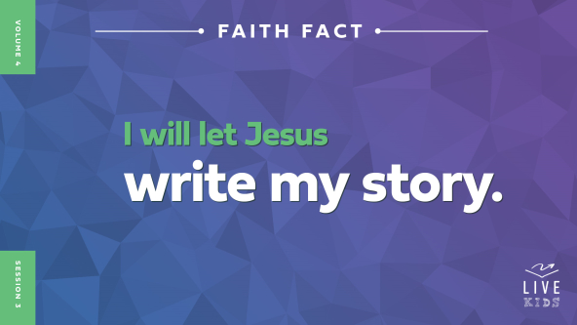

Let’s say the Faith Fact together while we pretend to write it in the air. Are you ready? *(Group response.)* **I will let Jesus write my story.** One more time. **I will let Jesus write my story.**

**Game**

**Cup Games**

Sometimes we think we know how our life should be going. Then suddenly, things completely change. Maybe you start going to a new school or your best friend moves away. Change can be hard, but it isn’t always a bad thing. When we let Jesus write our story, we can welcome change and let Him point us in a new direction.

Our Bible story today is about a woman who met Jesus at a well. A *well* is a deep hole dug in the ground that has water at the bottom. In Bible times, people didn’t have water faucets in their houses. Instead, they lowered a bucket or jar down into the well and pulled water out to drink or use for cleaning. Jesus simply asked the woman at the well for a drink. But by the time they finished talking, her life was changed forever!

Let’s play some games using drinking cups. We’ll have a boys’ team and a girls’ team. For each challenge, we’ll choose volunteers from each team, and the winning team will get a point. The team with the most points at the end will be the winner!

• *Choose kids to compete in the following activities. Play the* ***Countdown60 Video*** *for each challenge.*

• *Pyramid Race: Choose one kid from each team. Give each team ten cups. Let the volunteers race to make a pyramid.*

• *Cup Catch: Choose two kids from each team to see how many times they can toss a table tennis ball back and forth, catching it in their cups. If they drop the ball, the count starts over at zero. Their highest number of catches is their final score.*

• *Fill It Up: Choose two kids from each team to race to fill a cup with water using a spoon.*

• *Cup Stack: Stack ten cups with the marked-rim cup on the bottom. Choose one kid from each team to race to get that cup to the top by repeatedly moving the top cup to the bottom of the stack.*

• *Blow the Cup: Place one cup for each team upside down at one end of the table. Choose one kid from each team, and give each a straw. Challenge them to move their team’s cup to the other end of the table by blowing on it through the straw.*

Great job, everyone! We’ll find out more about that life-changing drink of water soon. But first let’s worship.

**Worship**

Let’s take some time to redirect our focus and pay attention to God. He loves it when we worship Him through singing. So let’s do that now!

• *Lead the kids in singing one or two praise songs. See suggestions at the beginning of the session.*

**Bible Lesson**

I love the time we spend focusing on God in worship. We listen for God’s voice, and He may speak to us—during worship, prayer, or any time. But when Jesus lived on earth, some people were able to talk with Him face-to-face. Wouldn’t that have been amazing? *(Group response)* When people met Jesus, their lives often changed completely. And He can change our life too! Before we get into our Bible story, let’s pray and ask Jesus to help us hear from Him.

**Prayer**

|  |
| --- |
| *Dear Jesus, thanks for the times You speak to us. We’re listening for Your voice. Help us to be open and ready to change when You point us in a new direction. We want You to write our story. Amen.* |

**Video Intro**

Just before we look at the Bible story, let’s watch this video.

• *Play* ***Bible Lesson Video****.*

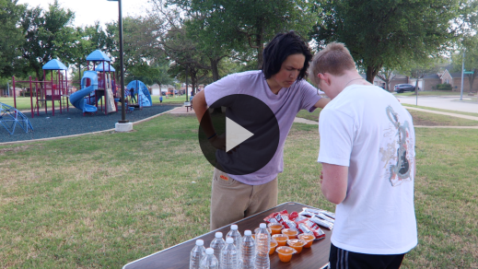

**Bible Story**

**A Woman’s Life Is Changed at a Well**

What a great intro to today’s Bible story! Dash really helped us understand what it looks like to let Jesus change us. Many Bible stories tell us how Jesus changed people’s lives. Can you think of some examples? *(Allow responses.)* Those are all amazing examples. Jesus was always pointing people in a new direction. He helped all kinds of people, whether they were in large crowds, smaller family groups, or on their own. Let’s look closer at what Jesus did to change one woman’s life.

**Teaching Time**

Sometimes we forget that Jesus is both God and human. It may seem odd, but Jesus had to rest, eat, and drink water during His time on earth just like we do. One day, He was thirsty and asked a Samaritan woman for a drink of water. *Samaritan* just means the woman was from a place called Samaria. By the end of their talk, Jesus had pointed the woman’s life in a brand-new direction. Remember the Faith Fact? Say it with me. **I will let Jesus write my story.** This Samaritan woman is a great example of that. Let’s find out more!

Grab your Bible or pull up a Bible app on your device. Turn to [John 4:5–30](https://ref.ly/logosref/Bible.Jn4.5-30).

• *In order to keep Large Group time moving along, we recommend that the leader reads the Scripture portions aloud.*

• *Optional: Remind the kids to mark this place with a bookmark, so they can read it on their own at home.*

**1. The Samaritan woman didn’t plan to meet Jesus.**

• *Show the* ***Teaching Point 1 Slide.***

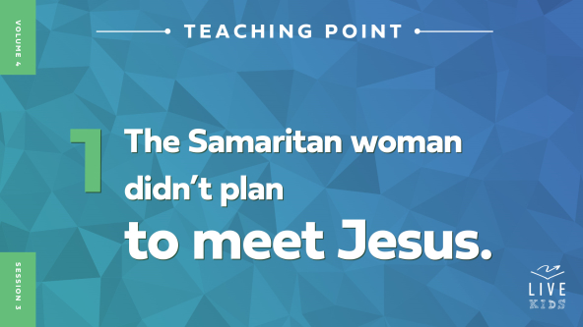

• *Read* [*John 4:5–14*](https://ref.ly/logosref/Bible.Jn4.5-14)*.*

Can you imagine Jesus asking you for a drink of water? *(Group response)* Jesus was very tired and thirsty after a long walk. So He stopped to rest beside a well in a Samaritan village. Jesus was a Jew, and it was unusual for Jews to even talk with Samaritans. But Jesus didn’t always do what people expected.

Jesus wanted a drink, but He didn’t have a rope or bucket to lower into the well. Soon, He saw a Samaritan woman coming to get water. It was a normal thing for her to do, and she probably wasn’t expecting to see anyone at the well. When Jesus saw her, He asked her to give Him a drink of water.

The Samaritan woman was surprised when Jesus started talking to her. It was unexpected for a Jew to speak to a Samaritan, because they often didn’t like each other. But Jesus was different. When the woman asked Jesus why He was talking to her, Jesus explained that she didn’t understand who He really was. If she knew who Jesus was, she would ask Him for help, and He’d give her living water. The living water He gave would keep people from ever being thirsty again. It would give them life that lasts forever. Wow! That conversation changed quickly!

What do you think the woman’s face looked like when Jesus offered her living water? *(Group response)* She was probably a little confused, but also excited to get her hands on this water that would keep her from ever being thirsty again.

**2. The Samaritan woman welcomed Jesus’ redirection.**

• *Show the* ***Teaching Point 2 Slide.***

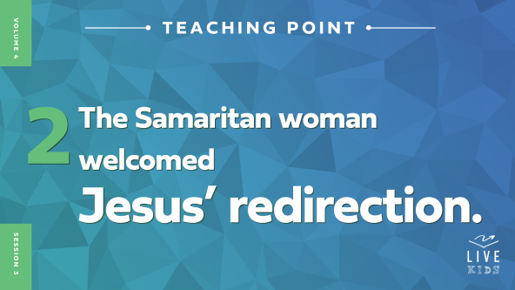

• *Read* [*John 4:15–26*](https://ref.ly/logosref/Bible.Jn4.15-26)*.*

How did the woman respond to Jesus’ offer of living water? *(Allow responses.)* The Samaritan woman wanted the living water from Jesus, but she didn’t quite understand what it was. She was probably thinking about this kind of water that our bodies need.

• *Hold up the bottle of water.*

Can you imagine drinking bottled water that quenched your thirst forever? *(Group response)* That would be pretty incredible! You’d never have to drink water again, and you’d never be thirsty again. That would be cool, but the living water Jesus offered the Samaritan woman was even better.

Do you remember how Jesus described the living water He was offering? *(Allow responses.)* Jesus said people who drank the living water would never be thirsty again. It would bubble up inside them, giving them life that lasts forever. This kind of water was completely different and unexpected. What Jesus was really offering the woman was the opportunity to believe in Him and receive eternal life.

Jesus had never met this woman before, but He knew details about her life and family. This showed her that Jesus was more than just a normal person. She realized He couldn’t have known those things unless He was a prophet. She wanted to learn more, so she kept asking Jesus questions.

The woman knew the Messiah—God’s chosen One—was coming. And guess what Jesus said next? He told her that *He* was the Messiah! Show me the reaction you think the woman might have had to this news. *(Group response)* Those are some great looks of surprise and shock. Now, let’s find out what she did with this amazing news.

**3. The Samaritan woman shared her story with everyone.**

• *Show the* ***Teaching Point 3 Slide.***

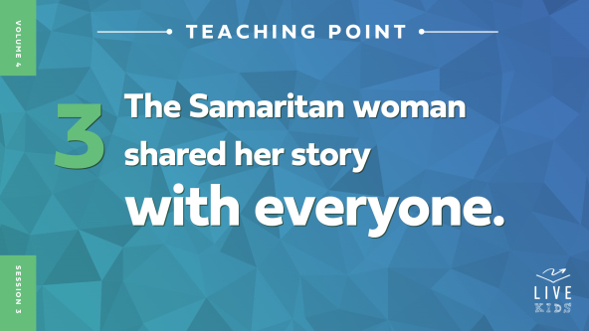

• *Read* [*John 4:27–30*](https://ref.ly/logosref/Bible.Jn4.27-30)*.*

Right after Jesus shared this incredible truth, His disciples came back from getting food in the village. They were surprised when they saw Jesus talking with a Samaritan woman. They didn’t know what had just happened.

It’s interesting that the Bible doesn’t tell us anything the woman said when Jesus told her this incredible truth. But we do know what she did. She was so excited about meeting Jesus that she couldn’t wait to spread the news. She left her water jar by the well and ran back to the village to tell everyone what Jesus had said to her.

Think about that for a moment. Why had the woman come to the well in the first place? *(Allow responses.)* That’s right, to get water from the well.

• *Hold up the bottle of water again.*

How did Jesus change the direction of the woman’s day? *(Allow responses.)* She didn’t even remember to take the jar of water home with her! How did Jesus change the direction of her life? *(Allow responses.)* Jesus’ words completely changed her thinking, and she had to tell everyone in her village about Him. Do you think the Samaritan woman was the only one whose life was redirected by Jesus that day? *(Group response)* No! In fact, when we read more of this chapter, we see that many other people who lived in her village came to hear Jesus’s message because of what the woman told them. After they heard Jesus’ teaching, many of them believed in Him too.

**Prayer and Response**

*Consider playing a worship song softly in the background while kids pray.*

Without a doubt, the Samaritan woman’s life changed after her talk with Jesus. She could’ve ignored Jesus when He asked for a drink. She could’ve said, “No, I’m too busy.” She could’ve decided not to believe that He was the Messiah. She could’ve kept living the same way as before. Instead, she believed Jesus. She welcomed His redirection, and her life was never the same.

Are you letting Jesus write your story? Or are you trying to make it up as you go along? Jesus wants to take our ordinary life and make it extraordinary. But our job is to change when He points us in a new direction. Sometimes it’s uncomfortable or scary to make the changes Jesus has for us. Maybe we’ll even have to give up some things we used to do or friends we used to hang out with.

But the story Jesus has for you is always better than the one you’d write for yourself. If you want Jesus to write your story, all you have to do is ask. Then listen and follow His leading. We can start doing that right now. Let’s pray quietly and listen to Jesus.

• *Take a few moments to let the kids pray quietly.*

• *Encourage kids to remain quiet and respectful during this time.*

**Prayer**

*Optional: Have the kids repeat phrases of the prayer after you.*

|  |
| --- |
| *Dear Jesus, thanks for showing me how You changed the Samaritan woman’s life story and made it better. I want You to write my story too. Help me to be ready when You point me in a new direction. Amen.* |

**Faith Verse**

Our Faith Verse reminds us that God will show us how to live, and we can trust Him. Sometimes that might look like a detour or a total U-turn from the direction we were heading in. But it’s always worth the extra time to go God’s direction. Let’s say the Faith Verse together.

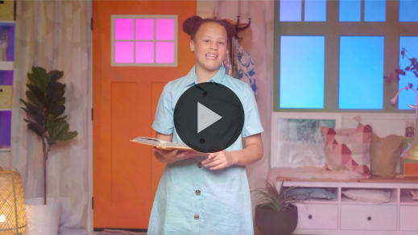

[Proverbs 3:5–6](https://ref.ly/logosref/Bible.Pr3.5-6)

Trust in the Lord with all your heart; do not depend on your own understanding. Seek his will in all you do, and he will show you which path to take.

When we seek God’s will and direction in our life, He will give it to us. We need to trust Him. We shouldn’t be afraid to follow His plan for our life. God’s plan is always better than our plan.

**Faith Fact**

Before we move on, let’s review our Faith Fact again. **I will let Jesus write my story.**

• *Show the* ***Faith Fact Slide****.*



Turn to a neighbor and take turns saying the Faith Fact. **I will let Jesus write my story**. *(Allow responses.)* Remember, we must give up control and allow Jesus to write our story. He will not force us to obey Him. Instead, He wants us to choose to follow His direction for our life.

• *Dismiss kids to Small Group time or to go home if your group time ends here.*

**Small Group**

**30 Minutes**

*This section can be done in conjunction with the large group or on its own if you do small groups with your kids. During Small Group time, the goal is to connect the kids with the Word of God and to each other. All activities are led by the small group leader.*

**Group Connection**

**Story Time!**

|  |
| --- |
| ***You Will Need***   * *Ball, one per group*   *No prep is needed for this activity.* |

You can try to write your own life story by making all your own decisions. But you’ll never write a story as amazing as the one Jesus would write for you. Let’s write a story or two together as a group and see what we come up with. We’ll pass this ball around, and when it comes to you, add one sentence to the story. Then pass the ball to someone else. I can’t wait to hear the stories we tell!

• *Play multiple rounds and create different stories each time.*

It was so interesting to hear the stories that we came up with as a group. I think we can all agree it’s better to let Jesus write our stories. We might think we know what’s best, but Jesus will always know better. He’ll do a better job leading our life than we could.

**Bible Lesson Recap**

• *If small group activities are not immediately following large group time, you may want to read the Bible story passage before the discussion.*

|  |
| --- |
| ***You Will Need***   * *Bibles for kids in the group to share*   *No prep needed for this activity.* |

**Bible Story Review: A Woman’s Life Is Changed at a Well** [**John 4:5–30**](https://ref.ly/logosref/Bible.Jn4.5-30)

Jesus traveled a lot, so He could teach and help people in different towns and villages. In [John 4](https://ref.ly/logosref/Bible.Jn4), we see that Jesus was tired and thirsty as He was walking from Judea to Galilee, so He stopped to rest at a well. While He sat by the well, He started talking to a local Samaritan woman, who had come to the well to get some water. The woman was confused about why Jesus was talking to her, because many Jews didn’t talk with Samaritans. Then Jesus said if she understood who He was, she’d ask Him for a drink and He’d give her living water.

The Samaritan woman wanted the living water Jesus spoke about. She soon realized that Jesus knew details about her life, even though they’d never met. She thought He must be a prophet, but He told her that He was more than that. He was the Messiah. She was so excited to get back to her village and tell everyone about Jesus that she left her water jar at the well and ran home. Jesus had pointed her life in a completely new direction. Many more Samaritans heard Jesus’ message because of what the woman said. When they heard His teaching for themselves, many believed in Him.

• *Optional: Give each kid a Bible and read the Bible story together.*

**Group Discussion**

*Feel free to use all or just a few questions as a jumping-off place for good discussion. Questions marked with * are designed for more conversation. Adjust the questions based on the age or maturity of your group. Typically, older kids will be able to dive a little deeper than younger ones.*

**Questions**

Why did the Samaritan woman come to the well?

* Why do you think Jesus talked to the woman, even though many Jews and Samaritans didn’t speak to each other?

Why did the woman need Jesus to point her life in a new direction?

If Jesus had offered you living water that day, do you think you would have understood what He meant? Why or why not?

Why do you think the woman believed that Jesus was the Messiah?

* How might the woman’s life have changed because of her talk with Jesus?

What did the woman do to let others know that Jesus had changed her life?

How can we be open to Jesus pointing our life in a new direction?

* Why is it important to allow Jesus to write your story?

**Live It**

**Faith Fact**

Our Faith Fact today is **I will let Jesus write my story.** Say that with me one more time. **I will let Jesus write my story.** How did Jesus write the Samaritan woman’s story? *(Allow responses.)* We don’t know what the rest of her life would have been like if she hadn’t believed Jesus that day. But we know what happened when she did believe. Her life was changed, and many other people had their lives changed too.

**Challenge**

Allowing Jesus to write your story is about so much more than just you. When Jesus writes your story, you can be sure that He’ll use you to share His love with others. He wants to change each person’s life. I have a challenge for you this week. Take five minutes every day and do three things: Ask Jesus what He wants your story to look like. Listen to what He says to your mind and heart. Write down anything you feel that Jesus is telling you.

**Prayer**

*Finish group discussion by sharing prayer requests and praise reports. Keep track of your small group’s prayer requests and review them each time you meet.*

• *Have kids share and pray for each other’s prayer requests.*

|  |
| --- |
| *Dear Jesus, help me to be open to You writing my story. Open my eyes and ears to know how You might want my life to change and go in a new direction. Amen.* |

**Faith Verse Review**

|  |
| --- |
| ***You Will Need***   * *Whiteboard* * *Dry erase marker* * *Whiteboard eraser*   ***Getting Ready***   * *Write the Faith Verse on the whiteboard.* |

Our Faith Verse is [Proverbs 3:5–6](https://ref.ly/logosref/Bible.Pr3.5-6). This verse reminds us to follow God’s path for our life. Let’s review it together.

• *Show* ***Faith Verse Video****.*



[Proverbs 3:5–6](https://ref.ly/logosref/Bible.Pr3.5-6)

Trust in the Lord with all your heart; do not depend on your own understanding. Seek his will in all you do, and he will show you which path to take.

Who thinks they have the Faith Verse memorized and is ready to say it for us? *(Allow responses.)*

**Faith Verse Fun**

**Faith Verse Wipeout**

This verse reminds us that God will lead us when we trust and follow Him. So let’s try to keep it in our mind and heart through this game.

Now, we’ll take turns erasing words and replacing them with lines before repeating the verse. Let’s see if we can keep saying the verse as the words disappear.

• *Each time the group recites the verse, have a volunteer erase one word from the verse. Then, say the verse again.*

• *Repeat until the whole verse is gone.*

• *If you’re short on time, consider erasing multiple words or phrases each turn.*

Great job, everyone! We’re learning our Faith Verse. I hope we never forget it.

**Activity Page**

**Name Acrostic**

|  |
| --- |
| ***You Will Need***   * ***Small Group Activity Page****, one per kid* * *Pencils or pens, one per kid* * *Crayons or markers*   ***Getting Ready***   * *Print copies of the* ***Small Group Activity Page****, one per kid.* |

This Activity Page will let you share some of the things Jesus has already written in your story.

• *Hand out a copy of the* ***Small Group Activity Page****, a pencil, and crayons to each kid.*

First, I want you to write your name in a column down the left side of the box on your page. Jesus has already given you amazing talents and a unique personality. So beside the letters of your first name, write one word or sentence about yourself that starts with each of the letters. For example, if your name has an A in it, you might write *athletic* or *awesome*. If it starts with B, you might write *bubbly* or *bold*. Let’s see what you can come up with.

• *Help kids with ideas if needed. This is a great time for you to affirm positive characteristics you see in them.*

**Dismissal**

Jesus’ conversation with the Samaritan woman was not what she was expecting when she went to the well that day. She went home with so much more than a jar of water. She met the Messiah and got to tell others about Him. Let’s pray and ask Jesus to radically redirect our life as He writes the story of our life too.

**Prayer**

|  |
| --- |
| *Dear Jesus, thank You for taking the time to guide us each day. Help us give up control and let You write the story for our life. Amen.* |

**Faith Fact Recap**

• *Show the* ***Faith Fact Slide****.*



Can anyone remember our Faith Fact? *(Group response)* Quick, find someone to say it, so you don’t forget it this week. *(Allow responses.)* Now let’s say it all together one more time before we go. **I will let Jesus write my story***.* Remember to take time each day to ask Jesus to write your story, listen to Him, and then follow His direction. See you next time. Have a great week!

• *Send home the* ***Small Group Activity Page.***

• *Remind parents that there are* ***Family Devotions*** *available on the app to do with their kid.*

• *Tell everyone the date and time for the next session.*